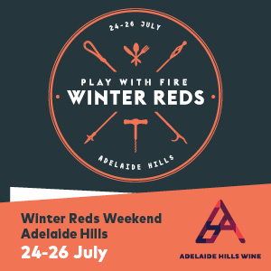

MEDIA RELEASE
JUNE 2015

FOLLOW YOUR NOSE TO THE ADELAIDE HILLS WINTER REDS WEEKEND THIS JULY

What: Winter Reds Weekend When: July 24 - 26, 2015
Where: Adelaide Hills Wine Region More info: adelaidehillswine.com.au

This July South Australians will awake from their winter slumber, pull on the jacket and scarf and head for the Hills for the 2015 Winter Reds Weekend.

Enticed by the gentle waft of lamb on the spit, slow cooked Coq au Vin and smoky BBQs matched to the wines of the beautiful Adelaide Hills, punters will be spoilt for choice across 30 different venues from Gumeracha to Macclesfield.

In its fifth year, the 2015 Winter Reds Weekend, from July 24 to 26, will be the largest on record with participating wineries offering a diverse range of events across Australia’s most awarded cool climate wine region, right on Adelaide’s door step.

Adelaide Hills Wine Region CEO, Robin Shaw, said the 2015 event is set to offer one of the most ‘mouth watering menus’ she’s seen in some time.

“The food on offer to match our world famous wines is really exciting,” she said. “We have assembled a stellar cast of local Hills chefs complemented by their city colleagues, who will be ‘Playing with Fire’ to boil, braise and barbecue their way through our fresh local produce all weekend.”

Culinary highlights of the weekend include Duncan Welgemoed from Africola cooking fireside at Murdoch Hill; A Pinot Noir dinner by candlelight at Mt Lofty Ranges Vineyard; and even a $250 per head, five course, degustation dinner in the Barrel Hall at Bird in Hand.

Barristers Block will have the spit roast crackling all weekend; Howard Vineyard is staging a Fireside Asian Banquet; and Ngeringa will again host the Feral Feast, focusing on out of the ordinary foods with their famous biodynamic wines.

Longview will celebrate their position in the ‘deep south’ of the Hills serving smoky BBQ and soul music; Adelaide Hills stalwart Petaluma will officially open its new cellar door in Woodside; and Sam Scott and local Italian wine expert David Ridge will host an alternative varietals masterclass.

“Winter Reds is also the ideal time to invite friends from Melbourne, Sydney or Brisbane,” Robin said.

“Interstate visitors can’t get enough of our great food and produce and well priced wines in a rustic atmosphere just 30 minutes from the centre of the city.

“This is a good time to remind them to book their flights and make their plans for an Adelaide Hills winter getaway weekend.”

The full program can be downloaded from adelaidehillswine.com.au

Media contact: Will Fuller | FULLER | will.fuller@fuller.com.au | 0437 651 095

